Description
The Electronic & Computer Engineering Technology (ECET) program leads to an Associate in Science degree and provides students with the skills and knowledge required for entry level employment within high-technology industry as electronic / electro-optic technicians, renewable energy technicians, telecom technicians, and network system administrators. Students learn fundamental engineering concepts, computer programming, mathematics, and physics relevant to a wide variety of industries on Maui. Training, equipment, and supplies are provided for 3-D printing and circuit board fabrication. Software applications for circuit simulation, CAD, finite element analysis, and microprocessor control are utilized. The program requires written and verbal proficiencies and emphasizes laboratory competencies. Internship and job placement opportunities in a variety of engineering technology positions are provided.
Mission Statement
The mission of the ECET program is to provide students with relevant and rigorous training and education needed for entry-level engineering technology positions in Maui County and to give graduates mobility within the field and the ability to adapt as the field changes.
The ECET program works closely with its high-technology industry advisory board to ensure students gain skills required for employment with local companies. In this respect, the program builds upon skills, duties and tasks considered critical by these prospective employers.

DESCRIPTION TAB
  - Demand Indicators: Unhealthy
The demand indicator, which states that the program is unhealthy, is based on the number of new and replacement positions in the state (16) and county prorated (1). The system for data collection allows for only one Classification of Instructional Programs (CIP) code: 15.1202, Computer Technology/Computer Systems Technology. This CIP code points to only one Standardized Occupational Classification (SOC) code: 17-3023, Electrical and Electronics Engineering Technicians. However, there are more occupations that AS ECET graduates can take on. According to the data shown in the table below there are at least 90 new and replacement positions in the state of Hawai`i.

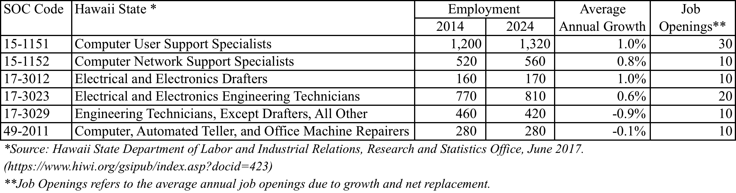

b. Efficiency Indicators: Cautionary
Students enrolled in ETRO classes are ECET majors: there are currently 26 active students enrolled in courses as part of the ECET program. However students who identify themselves as ECET majors (73) are not all enrolled in ETRO classes. As a consequence, the ratio of majors to FTE BOR appointed faculty does not represent the reality.
ANALYSIS TAB
- Analysis of the Program
- Briefly discuss any new significant program actions (new certificates, stopout, gain or loss of positions) as results of last year’s action plan.
Last year's (2015-2016) action plan | Results in 2016-2017 | Improvements for 2017-2018
The department will pilot Vertically Integrated Projects (VIP) as part of the Pre-Engineering Education Collaborative (PEEC II) grant activities. UHMC will participate by integrating STEM transfer students with ECET majors to work on projects for a total of the three-year grant period. | In summer 2017, 7 STEM transfer students (PEEC II participants) worked on an Undergraduated Research Project (URE) with ECET majors. They presented their poster/project at the PEEC II Symposium on Oahu in August 2017. | PEEC II participating students will work on a yearlong project (VIP), from fall 2017 through summer 2018, culminating in a poster to be presented at the PEEC II symposium on Oahu.
Continue the monitoring of AS ECET students academic plans for increased retention, graduation, and transition into the BAS ENGT degree program. We are anticipating 11 AS ECET graduates and 9 BAS ENGT students for fall 2017. | 10 ECET majors graduated with the AS, all within two years. 6 pursued with the BAS ENGT degree program. | Continue the monitoring of AS ECET students academic plans for increased retention, graduation, and transition into the BAS ENGT degree program.
A proposal request will be submitted to Tech Fee for the renewal of licenses for the academic year 2016-2017. | The Student Tech Fee Committee supported our request: an amount of $5,265.13 was approved to renew software licenses for ECET/ENGT students: Solidworks, MATLAB, Multisim, LAbView, and Zemax. | A proposal request will be submitted to Tech Fee for the renewal of licenses for the academic year 2017-2018.
Continue requesting funds to upgrade and maintain electronics equipment in the lab. | A protolaser circuit board machine was purchased and installed in the Voc Tech building. | Continue requesting funds to upgrade and maintain electronics equipment.
Meet with the advisory board twice a year. | ECET faculty met with the advisory board to review program curriculum, program map, P-SLOs, internships, and job placement. | Continue meeting with the advisory board twice for program improvement and CASLO assessment.

- If relevant, share a brief analysis for any Perkins Core Indicator not met.
- Goals and/or actions from previous assessment results
- Describe results from previous assessment goal and/or action implementation

  - PLO:
PLOs assessed in 2016-2017:
PLO #3: 5.4% of students show insufficient progress. These students failed written homework that utilizes mathematics: They had a hard time relating mathematics and applying mathematics to solve problems in optics.
PLO #5: 8.7% of students need improvement when setting up an experiment in a laboratory environment, and verifying mathematics using instrumentation. Homework and lab reports will increase efforts to reinforce the application of math skills to technical problems

Action plan: In 2016-2017, emphasis will be on lab reports in order to reinforce the application of math skills to technical problems.

  - CASLO: none

P-SLOs TAB
- PLO selected for assessment (click on the PLO assessed – it will turn green).
Demonstrate critical engineering technology skills and experiences such as: making existing technology operate, creating/selecting new technology, troubleshooting, calibrating, characterizing, and optimizing.

- Industry Validation (check all that apply):
Advisory Committee Meeting(s) _x_, How many? _1_
Did Advisory Committee discuss CASLO/PLO? No x_(CASLO), Yes_x (PLO)
Coop Ed Placements __ Fund raising activities/events __ Service Learning __
Provide program services that support campus and/or community
Outreach to public schools __
Partner with other colleges, states and/or countries __
Partner with businesses and organizations __
Other X Describe: _ECET Students capstone projects exhibition , April 2017

- Expected level of Achievement:
For the PLO assessed, 100 % of students completing the assignment/course expected to meet expectations for the assignment/course.
- Courses (or assignments) Assessed:
ETRO 161: Introduction to Optics and Photonics

- Assessment strategy/Instrument/Evidence (check all that apply):
Work Sample__ Portfolio__ Project __ Exam Writing Sample __
Other X Please explain: hands-on laboratory experiments, lab reports

- Results of program assessment:
a. The following were present at the PLO assessment:
Ned Davis (Maui Innovation Group)
Steven Griffin (Boeing)
Sharon Mielbrecht (Pacific Disaster Center)
Skip Williams (Boeing)
Elisabeth Dubuit (ECET/ENGT faculty)
Mark Hoffman (ECET faculty)

b. Strengths and weaknesses (best practices and educational gaps) found from PLO assessment analysis:

Strengths: ECET students enjoy hands-on experiments. They like to make things “work”. However, they can have a hard time solving technical problems using mathematics or analyzing experimental data. Following last year’s results of assessment of PLO #3 and 5 (see below), emphasis was put on lab reports in order to reinforce the application of math skills to technical problems.
(PLO #3: 5.4% of students show insufficient progress. These students failed written homework that utilizes mathematics: They had a hard time relating mathematics and applying mathematics to solve problems in optics.
PLO #5: 8.7% of students need improvement when setting up an experiment in a laboratory environment, and verifying mathematics using instrumentation. Homework and lab reports will increase efforts to reinforce the application of math skills to technical problems).

Weaknesses: Students work in teams of 2-3; each team needs to turn in a lab report; it is assumed that each student will participate in the editing of the report with the other team members; students in the same team will receive the same grade. There is no way to verify that all students participated in the editing of the lab report.

- Other comments:
Describe CASLO assessment findings and resulting action plans. Go to Laulima UHMC CASLO Assessment for your program’s “Assessment results” and summarize below.
There has been no assessment on Oral Communication. It appears that this CASLO does not apply to ETRO courses.

- Next steps:
For program learning outcomes (check all that apply):
Assess the next PLOX Review PLOsX Adjust assignment used for PLOX
Adjust course used for PLOX Meet with Advisory Committee X
Other___ Please explain:

- Please list any professional development needs you may have for your program.

